**RQ3: Assessment Methods**

|  |  |  |
| --- | --- | --- |
| **Assessment Methods** | **Studies** | **Total_1** |
| Peer Review | S1, S22, S49, S50, S76, S77 | 6 |
| Discussion | S16, S22, S30, S42, S49, S52, S59, S75, | 8 |
| Feedback | S1, S2, S11, S45, S50, S81 | 6 |
| Participation | S11, S30, S33, S54, S58, S75, S77 | 7 |
| Presentation | S10, S24, S35, S55, S65, S75 | 6 |
| Weekly Assignment | S30, S46, S55 | 3 |
| Quiz | S12, S14, S15, S16, S21, S32, S48, S74 | 8 |
| Exercise | S8, S12, S38, S40, S54, S58, S60, S62 | 8 |
| Homework | S22, S26, S43 | 3 |
| Inter-Group Evaluation | S65 | 1 |
| Architectural Kata | S52, S57 | 2 |
| Project | S1, S2, S6, S9, S10, S12, S13, S15, S16, S17, S20, S22, S24, S25, S32, S33, S34, S38, S48, S50, S57, S58, S65, S71, S74, S75 | 26 |
| Project Presentation | S32, S33, S35, S54, S68 | 5 |
| Examinations | S1, S8, S10, S16, S20, S24, S25, S26, S27, S30, S33, S34, S35, S36, S38, S41, S48, S54, S57, S60, S68, S75, S79 | 23 |
| Quiz/Test | S9, S15, S33, S43, S54, S55, S75 | 7 |
| Assignments | S11, S25, S34, S46, S48 | 5 |
| Self-Evaluation | S15, S41, S46, S48 | 4 |
| Reflection | S2, S11, S22, S24, S46 | 5 |
| Observation | S42, S46 | 2 |
| Prototype | S7, S47, S50, S83 | 4 |
| Decision Taking Template | S14, S61, S78 | 3 |
| Portfolio | S7, S8, S18, S45, S46, S58 | 6 |
| Kahoot!, | S60 | 1 |
| EasyChair | S58 | 1 |
| Client-Server Design Critic Tool | S70 | 1 |
| 3D Visualisation Tools | S82 | 1 |
| Canvas | S34 | 1 |

**Individual**

|  |  |  |  |
| --- | --- | --- | --- |
| **Theme** | **Assessment Methods** |  | **Studies** |
| **Formative Assessment Strategies** | Peer Review | Peer reviews as formative assessment tools. | S49 |
| Peer reviews for collaborative learning and improvements. | S50 |
| Assessment included peer evaluations, | S1 |
| peer reviews, | S22 |
| peer reviews, | S76 |
| Beside teachers' evaluation, students also face scrutiny of their peers. | S77 |
| Discussion | discussions as formative assessment tools. | S49 |
| Assessments are conducted using discussions (debates, public hearing formats) | S59 |
| focus group discussion was set up have discussion. | S52 |
| Employs interactive classroom discussions, | S16 |
|  | questions prompt with in-class discussion | S22 |
|  | In-class discussion to check the progress of each team and correct the problems in development in time | S75 |
| learners were assessed based on their written deliverables to the workshops, | S30 |
| Written deliveries to the workshops | S42 |
| Feedback | feedback for collaborative learning and improvements. | S50 |
| Formative feedback during teaching period (completed tasks) | S45 |
| stakeholder feedback. | S1 |
| Formative assessment (sprint retrospective for feedback) | S2 |
| Walkthrough evaluations as experimental assessment approach to evaluate system application usability. | S81 |
| • Leaderboards and points also served as motivational feedback. | S11 |
|  | Class Participation | Assessment based on participation, | S54 |
|  | Individual grades also depend on participation | S58 |
|  | Individual grades also depend on engagement during lectures. | S58 |
|  | observation on their workshop **participation** to check whether learners have gained sufficient capabilities to practically apply the concepts and methods in their workplace. | S30 |
|  | Class participations, | S33 |
|  | student participation logs. | S11 |
|  | Assessment includes participation (10%), | S75 |
|  | Teacher takes moderator role, assign roles to students and evaluates participants for achieving their role's goals using technical arguments and social skills. | S77 |
|  | Presentation | Continuous assessments through presentations were conducted via online platforms. | S55 |
|  | Midterm progress presentation (15%) | S35 |
|  | Students are assessed through a mix of presentations | S10 |
|  | presentation, | S24 |
|  | Oral presentation, | S65 |
|  | Assessment includes presentations (15%), | S75 |
|  | Weekly Assignments | Continuous assessments through assignments conducted via online platforms. | S55 |
|  | Weekly programming assignments, | S30 |
|  | 10 anonymous weekly assessments, | S46 |
|  | Quiz | Pre and post course assessment  Conceptual quizzes, | S48 |
|  | Collaborative quiz, | S32 |
|  | Pre-class test online | S74 |
|  | Preclass quizzes, | S12 |
|  | Conducted quizzes so that the student could prepare before having classes and assignments based on different domains | S14 |
|  | Employs structured assessments like daily quizzes, | S15 |
|  | Employs regular quizzes, | S16 |
|  | Pre exams as a practical work in three modelling: Business process, software function, data modelling | S21 |
|  | Exercise (practical) | Assessment is performed through practical | S60 |
|  | lab assignments (40%), | S38 |
|  | Lab exercise | S8 |
|  | Two practical assignments | S40 |
|  | Assessment based on exercises. | S54 |
|  | Assignments graded using predefined rubrics to apply the theory to practice. | S58 |
|  | lab exercise, lab assignments, | S12 |
|  | Exercises and assignments to promote student’s participant in class | S62 |
|  | Homework | assigning homework | S43 |
|  | questions prompt with homework activities, | S22 |
|  | Homework assessment, | S26 |
|  | Inter-Group Evaluation | Other groups will evaluate their works by asking questions and proposing suggestions for future improvement. | S65 |
|  | Architectural Kata | Architectural Kata Workshops where software architects evaluate their solutions and focus group discussion was set up have discussion. | S52 |
|  | Architectural Kata is set up with participants divided into teams that work together. The moderator assigns a kata problem to each team (Discussion, peer-review, voting). | S57 |
| **Summative Assessment Practices** | Project | Project-based grading (final project) | S48 |
|  | Final assessment based on structural stability and creativity. | S50 |
|  | Book chapters evaluated for content, depth, writing, and originality. | S58 |
|  | Problem-based group projects (three assignments to design, document and evaluate architectural solutions for a software project case). | S57 |
|  | team deliveries, | S32 |
|  | project, | S33 |
|  | Uses a combination of formative and summative assessments, including projects | S34 |
|  | 360-degree summative assessment (self, peer, observer) perspective | S2 |
|  | supervised projects – individual work (20%), | S38 |
|  | final project deliverables, | S1 |
|  | Deliverable submission rates and software quality metrics.  Instructor evaluations of project completion | S6 |
|  | capstone project evaluations | S9 |
|  | Students are assessed through a mix of practical projects and capstone work | S10 |
|  | group project | S12 |
|  | Partially mentions continuous and project-based assessment | S13 |
|  | Employs structured assessments like project work | S15 |
|  | Employs paper-based project submissions, | S16 |
|  | Small projects on PaaS | S17 |
|  | Group project | S20 |
|  | Project-based assessments, | S22 |
|  | Real-world problem project, | S24 |
|  | Projects, | S25 |
|  | projects | S65 |
|  | Two comprehensive projects | S71 |
|  | Grading on final project experimental report and source codes | S74 |
|  | Assessment includes project (40%) | S75 |
|  | Project Presentation | Assessment based on presentation of risk findings for all software qualities. | S54 |
|  | project presentation. | S32 |
|  | final presentation, | S33 |
|  | Final project presentation and robot competition (30%) | S35 |
|  | Final Software Architecture Document presentation with help of Archinotes | S68 |
|  | Examinations (Oral and Written) | Project-based grading (midterm | S48 |
|  | Assessment based on written examination | S54 |
|  | Assessment is performed through final exams. | S60 |
|  | Individual final written examination. | S57 |
|  | formal assessment (midterm, final examination) | S30 |
|  | written examinations (three). | S33 |
|  | Uses a combination of formative and summative assessments, including exams. | S34 |
|  | Examinations (55%) | S35 |
|  | Group-based project exams | S36 |
|  | objective test – final exam (40%). | S38 |
|  | Final exams | S41 |
|  | Final exams | S1 |
|  | final exam project,  oral exam session | S8 |
|  | Students are assessed through a mix of written exams | S10 |
|  | Employs final examinations, | S16 |
|  | Individual written exmnations | S20 |
|  | closed book examination | S24 |
|  | Oral exam, Written exam, | S25 |
|  | final exam | S26 |
|  | Traditional gradings (exams) | S27 |
|  | Two written midterms | S68 |
|  | Assessment includes exam (25%), | S75 |
|  | Two-fold bachelor’s exam consisting of written exams that evaluates the knowledge acquisition and thesis defending. (Bloom’s Taxonomy) | S79 |
|  | Quiz/Test | Assessment based on in-class quizzes | S54 |
|  | Continuous assessments through quizzes conducted via online platforms. | S55 |
|  | quizzes, | S33 |
|  | Quizzes, | S43 |
|  | Assessment includes quizzes (10%), | S75 |
|  | Employs structured assessments like test. | S15 |
|  | Students were assessed using tests, | S9 |
|  | Assignments | Project-based grading (assignments, | S48 |
|  | Assignments | S34 |
|  | Assessment involved:  • Quantitative metrics: code quality, test coverage, assignment completion, | S11 |
|  | 11 assignments, | S46 |
|  | Assignments, | S25 |
| **Experiential Assessment Techniques** | Self-Evaluation | Self-evaluation surveys, | S48 |
|  | Individual assessment at each Sprint | S41 |
|  | 18 project reports that included team and self-evaluation | S46 |
|  | Self-explanatory and their description in elided for brevity. | S15 |
|  |  |  |
|  |  |  |
|  | Reflection | self-reflection at end of each session, | S22 |
|  | 18 project reports that included reflection, | S46 |
|  | Qualitative feedback: student reflections, surveys, and performance trends. | S11 |
|  | Formative assessment (sprint retrospective for feedback) | S2 |
|  | reflection on learning journey, | S24 |
|  | Observation | Observe their participation in workshops | S42 |
|  | anecdotal observation, | S46 |
|  | Prototype | Trial-and-error testing to evaluate students' understanding of design rules, form stability, and material behaviour. | S50 |
|  | Constructions of prototypes (2) | S47 |
|  | students are evaluated based on:  • Software product quality (final deliverables). | S7 |
|  | Analysing the exercise and creating MVC class diagram and develop the final project (prototype) | S83 |
|  | Decision Taking Template | There is no definite assessment methods used but however they were provided with Decision Taking Templates which would have helped them to log and reflect reasoning for their decisions. | S61 |
|  | Uses argumentation theory and critical questioning as an assessment tool to evaluate student design decisions. | S14 |
|  | Decision preparation template and decision taking template | S78 |
|  | Portfolio | designing project documentation, | S8 |
|  | • Process and methodology adherence  • Architecture documentation and decision-making process. | S7 |
|  | Delayed summative assessment (portfolio: Learning Summary report) at the end of unit’s delivery | S45 |
|  | Individual grades also depend on activity journals | S58 |
|  | individual contributions | S46 |
|  | Architectural documentation consisting of questions | S18 |
| **Technology Assessment Tools** | Kahoot! | Assessment is performed through quizzes (using Kahoot!) | S60 |
| EasyChair | Peer review process using EasyChair to simulate academic review practices | S58 |
|  |  |  |
| Client-Server Design Critic Tool | Submission of Design and feedback is provided with help of CSDCT tool. rovides an automated critiquing via  comparative critiquing and example-based approach. It  provides the students with an easy-to-use tool and facilitates  the self-learning process. | S70 |
| 3D Visualisation Tools | Use of 3D visualisation technologies (VR and AR) – bridging the gap between practice and theories. | S82 |
| Canvas | Uses a combination of formative and summative assessments, including quizzes (Canvas) | S34 |
|  |  |  |

|  |  |  |  |
| --- | --- | --- | --- |
| **Reviewer** | **Theme** | **Assessment Methods** | **Paper Study ID** |
|  |  | Pre- and post-course assessment | S48 |
|  |  | Conceptual quizzes, | S48 |
|  |  | Self-evaluation surveys, | S48 |
|  |  | Project-based grading (final project) | S48 |
|  |  | Project-based grading (assignments, | S48 |
|  |  | Project-based grading (midterm | S48 |
|  |  | Competency-based assessment aligned with an accredited skills framework. | S49 |
|  |  | Peer reviews as formative assessment tools. | S49 |
|  |  | discussions as formative assessment tools. | S49 |
|  |  | Peer reviews for collaborative learning and improvements. | S50 |
|  |  | feedback for collaborative learning and improvements. | S50 |
|  |  | Trial-and-error testing to evaluate students' understanding of design rules, form stability, and material behaviour. | S50 |
|  |  | Final assessment based on structural stability and creativity. | S50 |
|  |  | Assessments are conducted using debates. | S59 |
|  |  | Assessments are conducted using public hearing formats | S59 |
|  |  | Assessments are conducted using discussions | S59 |
|  |  | Assessment based on participation, | S54 |
|  |  | Assessment based on written examination | S54 |
|  |  | Assessment based on in-class quizzes | S54 |
|  |  | Assessment based on exercises. | S54 |
|  |  | Assessment based on presentation of risk findings for all software qualities. | S54 |
|  |  | Individual grades also depend on participation | S58 |
|  |  | Individual grades also depend on activity journals | S58 |
|  |  | Individual grades also depend on engagement during lectures. | S58 |
|  |  | Assessment is performed through quizzes (using Kahoot!) | S60 |
|  |  | Assessment is performed through practical | S60 |
|  |  | Assessment is performed through final exams. | S60 |
|  |  | Architectural Kata Workshops where software architects evaluate their solutions and focus group discussion was set up have discussion. | S52 |
|  |  | focus group discussion was set up have discussion. | S52 |
|  |  | Assessment methods used was by evaluating team assignments and brainstorming outputs based on technical aspects (quality of solutions, comprehension of concepts) and interpersonal skills (time to present their decisions, individual participation, peer-review contributions, contribution to peer-reviews, their willingness to accept peers’ requests). | S56 |
|  |  | Assignments graded using predefined rubrics to apply the theory to practice. | S58 |
|  |  | Book chapters evaluated for content, depth, writing, and originality. | S58 |
|  |  | Peer review process using EasyChair to simulate academic review practices | S58 |
|  |  | There is no definite assessment methods used but however they were provided with Decision Taking Templates which would have helped them to log and reflect reasoning for their decisions. | S61 |
|  |  | Continuous assessments through assignments conducted via online platforms. | S55 |
|  |  | Continuous assessments through quizzes conducted via online platforms. | S55 |
|  |  | Continuous assessments through presentations were conducted via online platforms. | S55 |
|  |  | Problem-based group projects (three assignments to design, document and evaluate architectural solutions for a software project case). | S57 |
|  |  | Individual final written examination. | S57 |
|  |  | Architectural Kata is set up with participants divided into teams that work together. The moderator assigns a kata problem to each team.(Discussion, peer-review, voting) | S57 |
|  |  |  | S29 |
|  |  | Weekly programming assignments, | S30 |
|  |  | formal assessment (midterm, final examination) | S30 |
|  |  | observation on their workshop **participation** to check whether learners have gained sufficient capabilities to practically apply the concepts and methods in their workplace. | S30 |
|  |  | learners were assessed based on their written deliverables to the workshops, | S30 |
|  |  | Followed a two-pronged approach for evaluation using *EasyAuthor.*  (i) implementation of a platform for modeling instructional design variations (ii) use of the platform for modeling instructional design variations for 8 Indian languages. | S31 |
|  |  | Collaborative quiz, | S32 |
|  |  | team deliveries, | S32 |
|  |  | project presentation. | S32 |
|  |  | Class participations, | S33 |
|  |  | quizzes, | S33 |
|  |  | project, | S33 |
|  |  | final presentation, | S33 |
|  |  | written examinations (three). | S33 |
|  |  | Uses a combination of formative and summative assessments, including projects | S34 |
|  |  | Uses a combination of formative and summative assessments, including quizzes (Canvas) | S34 |
|  |  | Uses a combination of formative and summative assessments, including exams. | S34 |
|  |  | Assignments | S34 |
|  |  | Examinations (55%) | S35 |
|  |  | Midterm progress presentation (15%) | S35 |
|  |  | Final project presentation and robot competition (30%) | S35 |
|  |  | Group-based project exams | S36 |
|  |  | Used Technology Assessment Model (TAM) to assess the perceptions of software architects as to whether the redesigned A-Plus Architect tools would be useful and usable. | S37 |
|  |  | lab assignments (40%), | S38 |
|  |  | supervised projects – individual work (20%), | S38 |
|  |  | objective test – final exam (40%). | S38 |
|  |  | Five groups were allowed with use mobile devices for their projects) Mobile-PBL), while other five groups implemented using PBL to assess the effectiveness of MPBL by assessing the completion rate. | S39 |
|  |  | Two practical assignments | S40 |
|  |  | Individual assessment at each Sprint | S41 |
|  |  | Final exams | S41 |
|  |  | Written deliveries to the workshops | S42 |
|  |  | Observe their participation in workshops | S42 |
|  |  | Quizzes, | S43 |
|  |  | assigning homework | S43 |
|  |  | Uses qualitative evaluation with stakeholders for assessment. | S44 |
|  |  | Formative feedback during teaching period (completed tasks) | S45 |
|  |  | Delayed summative assessment (portfolio: Learning Summary report) at the end of unit’s delivery | S45 |
|  |  | anecdotal observation, individual contributions | S46 |
|  |  | 11 assignments, | S46 |
|  |  | 10 anonymous weekly assessments, | S46 |
|  |  | 18 project reports that included team and self-evaluation | S46 |
|  |  | 18 project reports that included reflection, | S46 |
|  |  | Constructions of prototypes (2) | S47 |
|  |  | Assessment included peer evaluations, | S1 |
|  |  | final project deliverables, | S1 |
|  |  | stakeholder feedback. | S1 |
|  |  | Final exams | S1 |
|  |  | Formative assessment (sprint retrospective for feedback) | S2 |
|  |  | 360-degree summative assessment (self, peer, observer) perspective | S2 |
|  |  | The study reviews competency assessment models, including tools for measuring software engineers’ capabilities but not in an academic student context. | S3 |
|  |  |  | S4 |
|  |  | The study evaluates Bayesian network-based inference vs. manual learning style tests for student assessment. | S5 |
|  |  | Automated tracking of collaboration and system usage.  Deliverable submission rates and software quality metrics.  Instructor evaluations of project completion | S6 |
|  |  | students are evaluated based on:  • Software product quality (final deliverables). | S7 |
|  |  | • Process and methodology adherence  • Architecture documentation and decision-making process. | S7 |
|  |  | used student feedback surveys as the primary assessment method and analyzed project-based evaluation using SonarQube for software quality  lab exercise, | S8 |
|  |  | final exam project, | S8 |
|  |  | designing project documentation, | S8 |
|  |  | oral exam session, | S8 |
|  |  | Students were assessed using tests, | S9 |
|  |  | capstone project evaluations | S9 |
|  |  | Students are assessed through a mix of practical projects, | S10 |
|  |  | Students are assessed through a mix of written exams | S10 |
|  |  | Students are assessed through a mix of presentations | S10 |
|  |  | Students are assessed through a mix of capstone work, | S10 |
|  |  | Assessment involved:  • Quantitative metrics: code quality, test coverage, assignment completion, | S11 |
|  |  | student participation logs. | S11 |
|  |  | Qualitative feedback: student reflections, surveys, and performance trends. | S11 |
|  |  | • Leaderboards and points also served as motivational feedback. | S11 |
|  |  | The study evaluates rubric-based, point-based, and specification-based grading systems to assess individual and group work.  Preclass quizzes, | S12 |
|  |  | lab exercise, lab assignments, | S12 |
|  |  | group project | S12 |
|  |  | Partially mentions continuous and project-based assessment | S13 |
|  |  | Uses argumentation theory and critical questioning as an assessment tool to evaluate student design decisions. | S14 |
|  |  | Conducted quizzes so that the student could prepare before having classes and assignments based on different domains | S14 |
|  |  | Employs structured assessments like daily quizzes, | S15 |
|  |  | Employs structured assessments like project work | S15 |
|  |  | Employs structured assessments like test. | S15 |
|  |  | Self-explanatory and their description in elided for brevity. | S15 |
|  |  | Employs regular quizzes, | S16 |
|  |  | Employs interactive classroom discussions, | S16 |
|  |  | Employs paper-based project submissions, | S16 |
|  |  | Employs final examinations, | S16 |
|  |  | Employed the Technology Acceptance Model (TAM) evaluating student perceptions of ease of use and usefulness of PaaS-based SA projects through qualitative and quantitative student feedback, reflections, and practical assessments.  Small projects on PaaS | S17 |
|  |  | Architectural documentation consisting of questions | S18 |
|  |  |  | S19 |
|  |  | Group project and | S20 |
|  |  | Individual written exmnations | S20 |
|  |  | Pre exams as a practical work in three modelling: Business process, software funcstions, data modelling | S21 |
|  |  | Project-based assessments, | S22 |
|  |  | questions prompt with homework activities, | S22 |
|  |  | questions prompt with in-class discussion | S22 |
|  |  | peer reviews, | S22 |
|  |  | self-reflection at end of each session, | S22 |
|  |  |  | S23 |
|  |  | Real-world problem project, | S24 |
|  |  | presentation, | S24 |
|  |  | reflection on learning journey, | S24 |
|  |  | closed book examination | S24 |
|  |  | Projects, | S25 |
|  |  | Assignments, | S25 |
|  |  | Oral exam, Written exam, | S25 |
|  |  | Homework assessment, | S26 |
|  |  | final exam | S26 |
|  |  | Traditional gradings (exams) | S27 |
|  |  | Ranking Task activities by analysing the scenarios | S28 |
|  |  | Exercises and assignments to promote student’s participant in class | S62 |
|  |  |  | S63 |
|  |  |  | S64 |
|  |  | projects | S65 |
|  |  | Oral presentation, | S65 |
|  |  | Other groups will evaluate their works by asking questions and proposing suggestions for future improvement. | S65 |
|  |  |  | S66 |
|  |  |  | S67 |
|  |  | Two written midterms | S68 |
|  |  | Final Software Architecture Document presentation with help of Archinotes | S68 |
|  |  |  | S69 |
|  |  | Submission of Design and feedback is provided with help of CSDCT tool. rovides an automated critiquing via  comparative critiquing and example-based approach. It  provides the students with an easy-to-use tool and facilitates  the self-learning process. | S70 |
|  |  | Two comprehensive projects | S71 |
|  | Duplicate |  | S72 |
|  |  |  | S73 |
|  |  | Grading on final project experimental report and source codes | S74 |
|  |  | Pre-class test online | S74 |
|  |  | In-class discussion to check the progress of each team and correct the problems in development in time | S75 |
|  |  | Assessment includes presentations (15%), | S75 |
|  |  | Assessment includes quizzes (10%), | S75 |
|  |  | Assessment includes exam (25%), | S75 |
|  |  | Assessment includes participation (10%), | S75 |
|  |  | Assessment includes project (40%)​ | S75 |
|  |  | peer reviews, | S76 |
|  |  | Teacher takes moderator role, assign roles to students and evaluates participants for achieving their role's goals using technical arguments and social skills. | S77 |
|  |  | Beside teachers' evaluation, students also face scrutiny of their peers. | S77 |
|  |  | Decision preparation template and decision taking template | S78 |
|  |  | Two-fold bachelor’s exam consisting of written exams that evaluates the knowledge acquisition and thesis defending. (Bloom’s Taxonomy) | S79 |
|  |  | The study uses Kirkpatrick’s four-level evaluation model (Reaction, Learning, Behavior, Results), surveys, interviews, and video reflections to assess the impact of the teaching strategy. | S80 |
|  |  | Walkthrough evaluations as experimental assessment approach to evaluate system application usability. | S81 |
|  |  | Use of 3D visualisation technologies (VR and AR) – bridging the gap between practice and theories. | S82 |
|  |  | The study uses a customized System Usability Scale (SUS) survey with Likert scales to evaluate students’ perceptions of the tool's ease of use, learning curve, and usefulness.  Analysing the exercise and creating MVC class diagram and develop the final project (prototype) | S83 |

**RQ3: Findings**

The findings of the assessment methods from 60 studies from 82 reviewed articles have been categorised into four themes based on their nature and purpose of the assessment. The four thematic concepts emerged from the three foundational concepts of assessments: Assessment for Learning, Assessment of Learning and Assessment as Learning. Assessment for Learning (AfL, William 2011) involves the information for the improved performance and further actions to improve learning. Assessment of Learning (AoL, Crooks) is judging the performance and measuring outcomes after the learning activity. Assessment as Learning (AaL, Endnote) involves student in self-assessment and self-directed learning to improve the learning process.

In this paper, the Formative Assessment Strategies is related to AfL, the Summative Assessment Practices is related to AoL and the Experiential Assessment Techniques is related to AaL. While the fourth theme, the Technology Assessment Tools is a supplement to the other three assessment methods since it is incorporated in the online tools or platform for the assessment purposes which can provide instance feedback and grading.

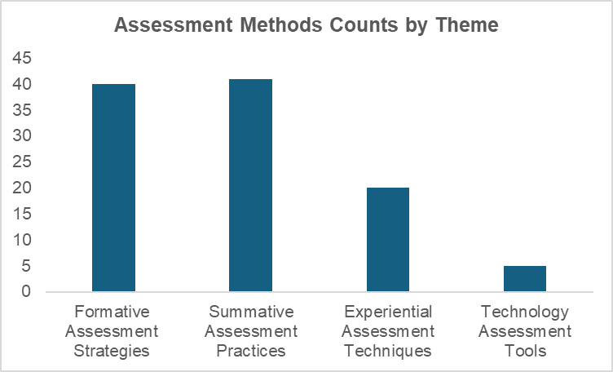

The Figure above shows frequency of assessment methods by the themes used from the reviewed articles of which summative and formative assessment strategies are widely used. Majority of the paper mentioned the use of more than two assessment approaches to assess the learning of student. While there are papers that did not mention about of use of assessment methods. We found out that there are five different technology tools that can enhance the assessment method.

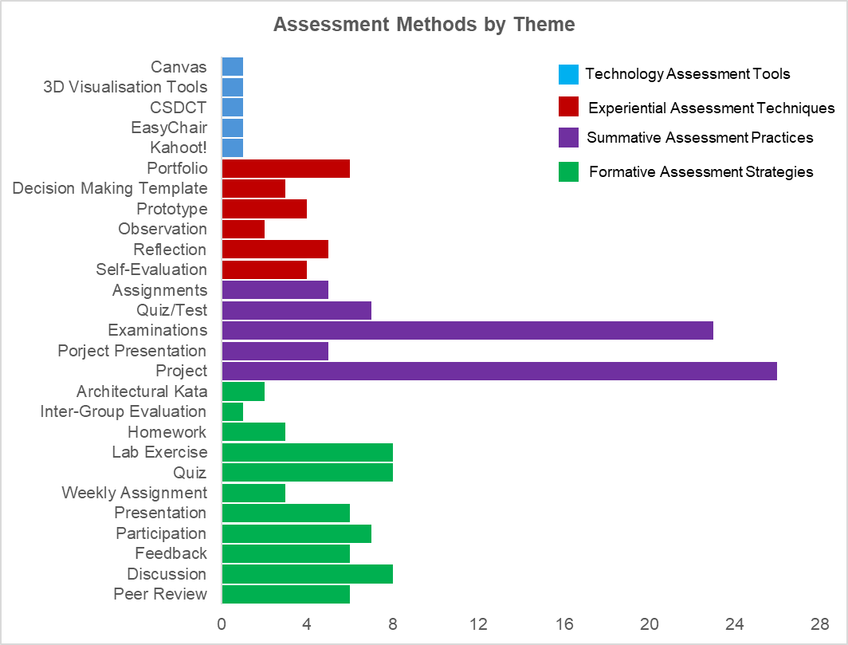

For the formative assessment, the frequently used methods were discussion, exercises and quiz while the least used is inter-group evaluation (n = 1) and Architectural Kata (n = 2). It is found out that they implement the pre-class quiz before coming to the class to check their level of understanding on certain topics and pre assessment of the course or content. They provided the reading materials and let the students to attempt the quiz, so the educators assess them. There are also other formative assessment techniques such as presentation (n = 6) where they do oral presentation on midterm progress, the class participation (n = 7) assessed through engagement and participation log, give peer review (n = 6) by the students for collaborative learning and improvements, and feedback (n = 6) are usually given by the assessors (teachers or other stakeholders).

The examinations and project form of assessment were widely used from the summative assessment practices; in fact, they are top two assessment tools used from the reviewed articles. Examinations form of assessment is widely used assessment strategies in teaching of software architecture with 23 of the reviewed articles mentioned about it. They conducted the examinations in oral and written form of exams at the mind and end of the semester, closed book exam (S24) and group-based project exams (S36). The project-based assessment (n=26) is widely used in the form of the project such as capstone project, writing book chapter, practical projects, real-world project problem and even individual project. They were evaluated at the end of the session and along with this, project presentation (n=5) was also integrated to present their findings. Other methods such as quizzes or test (n = 7) and assignments (n = 5) were also used for the grading the learner's performance. Quizzes, tests and assignments were assessed in the classroom which took after the lesson for short duration.

For the experiential assessment strategies, the reflective writing journal or portfolio (n = 6) was frequently used, followed by self-reflection (n =5). In the portfolio, the learners were required to maintain the documentation of the individual contributions, process, methodology, decision-making process and other related questions. The reflection is done through reflection on team project, at the end of each session or sprint, and reflection on their own learning journey. Self-evaluation was done through self-evaluation at end of each session (S22), individual assessment at each sprint (S41) and self-evaluation survey (S48). The other assessment techniques mentioned in the reviewed articles were also observation (n = 2), prototyping (n = 4) and decision-making template (n = 3) which helped the learners to log and reflect reasoning for their decisions.

There were six technology-based assessment tools that were used to enhance the assessment. They are the platforms used as supplementary for the summative and formative assessment strategies. The Canvas (S34) and Kahoot! (S60), they were used to conduct quizzes, EasyChair (S58) and CSDCT (S70) as peer review process and instant feedback giving respectively. While 3D visualisation technologies (S82) with use of AR and VR help to bridge the gap between theories and practice.

The detailed assessment techniques found from the papers under each theme are mentioned below.

|  |  |  |  |
| --- | --- | --- | --- |
| **Theme** | **Assessment Methods** | **Studies** | **Total_2** |
| **Formative Assessment Strategies** | Peer Review, Discussion, Participation, Presentation, Weekly Assignment, Quiz, Exercise, Homework, Inter-Group Evaluation, Architectural Kata | S1, S2, S8, S10, S11, S12, S14, S15, S16, S21, S22, S24, S26, S30, S32, S33, S35, S38, S40, S42, S43, S45, S46, S48, S49, S50, S52, S54, S55, S57, S58, S59, S60, S65, S62, S74, S75, S76, S77, S81 | 40 |
| **Summative Assessment Practices** | Project, Project Presentation, Examinations, Quiz/Test, Assignments, | S1, S2, S6, S8, S9, S10, S11, S12, S13, S15, S16, S17, S20, S22, S24, S25, S26, S27, S30, S32, S33, S34, S35, S36, S38, S41, S43, S46, S48, S50, S54, S55, S57, S58, S60, S65, S68, S71, S74, S75, S79, | 41 |
| **Experiential Assessment Techniques** | Self-Evaluation, Reflection, Observation, Prototype, Decision Taking Template, Portfolio, | S2, S7, S8, S11, S14, S15, S18, S22, S24, S41, S42, S45, S46, S47, S48, S50, S58, S61, S78, S83 | 20 |
| **Technology Assessment Tools** | Kahoot!, EasyChair, Client-Server Design Critic Tool, 3D Visualisation Tools, Canvas, | S34, S58, S60, S70, S82 | 5 |

**RQ3: Discussion**

From the reviewed literature, the significant finding is the use of multiple assessment strategies in software architecture teaching. The combined use of different assessment techniques has been shown to enhance the learning engagement and performance evaluation. As per our own experiences being students, when the tutors assess our learning through multiple means of assessment methods, we feel that our learning is being improved drastically.

The experiential learning techniques usually improve the learning process and serve as bridge between formative and summative assessment. When educators strategically blend this approach with other assessment techniques, it can support the holistic view of student development, emphasising not only on content mastery, but also collaboration, reflection, evaluation and peer reviewing can help to gain some skills which are critical in software architecture industry.

The Architectural Kata structure stands out as a promising but rarely used tool. It stimulates realistic design challenges, requiring stduents to make architectural decisions, prototypes solutions, and engage in self and peer reviews during discussion. This approach inherently blends all four assessment types, fostering industry-ready skills like problem solving and reflective practice which are critical. However, its limited adoption in curricula highlights an opportunity for educators to rethink assessment design in future.